Day2 Activity 3 Worksheet
Use both patterns to describe from place A to place B
Place 1 + 离 + Place 2+ 有＃＃里(路)
Place 1 + 离 + Place 2 + Adv. + 近 jìn / 远 yuǎn

(2)

(3) | (4)
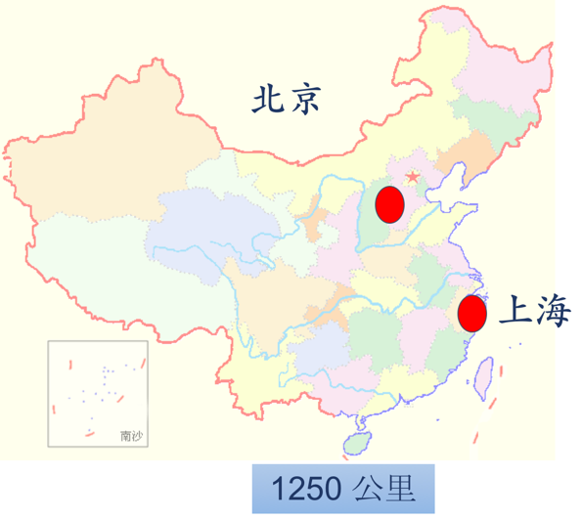 | 